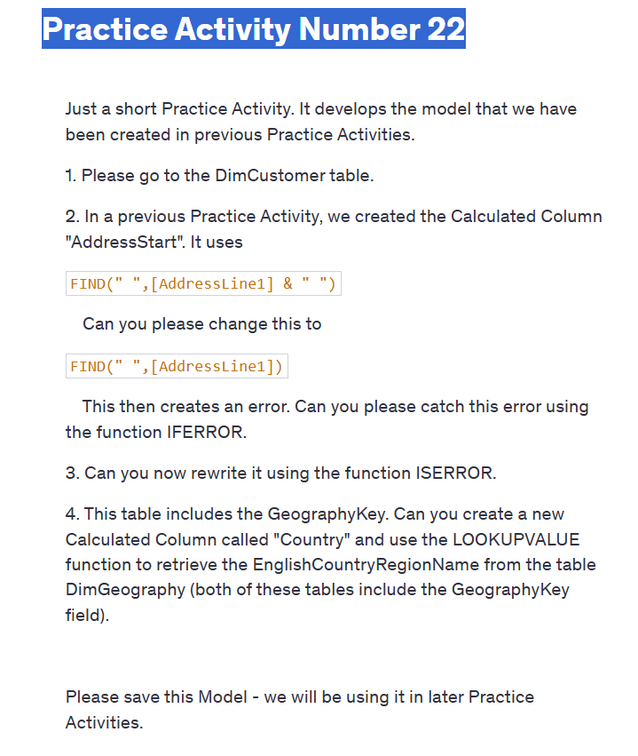

Practice Activity Number 22

Just a short Practice Activity. It develops the model that we have been created in previous Practice Activities.

1. Please go to the DimCustomer table.

2. In a previous Practice Activity, we created the Calculated Column "AddressStart". It uses

FIND(" ",[AddressLine1] & " ")

Can you please change this to

FIND(" ",[AddressLine1])

This then creates an error. Can you please catch this error using the function IFERROR.

3. Can you now rewrite it using the function ISERROR.

4. This table includes the GeographyKey. Can you create a new Calculated Column called "Country" and use the LOOKUPVALUE function to retrieve the EnglishCountryRegionName from the table DimGeography (both of these tables include the GeographyKey field).

Please save this Model - we will be using it in later Practice Activities.